**Storage class**

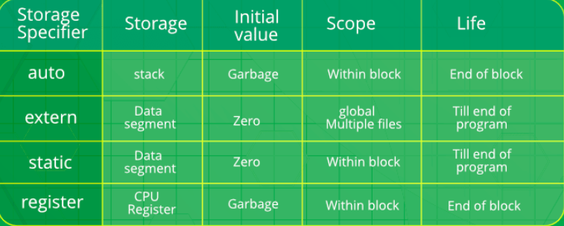

* A declaration can be done any number of times but definition only once.
* When extern is used with a variable, it’s only declared, not defined.
* Static variables have a property of preserving their value even after they are out of their scope!
* we cannot obtain the address of a register variable using pointers.
* The default value of static is 0.
* Volatile keyword - The volatile keyword is intended to prevent the compiler from applying any optimizations on objects that can change in ways that cannot be determined by the compiler.
* We can change the value of const qualifier only by using pointers.
* In C, static variables can only be initialized using constant literals
* Registers are faster than memory to access
* We cannot use more than one storage classes at the same time.
* Register cannot be used globally.